UNITED STATES
SECURITIES AND EXCHANGE COMMISSION
Washington, D.C. 20549
___________________________________________
FORM 8-K
___________________________________________
CURRENT REPORT
Pursuant to Section 13 or 15(d)
of the Securities Exchange Act of 1934
Date of Report (Date of Earliest Event Reported): June 6, 2026
___________________________________________
NURIX THERAPEUTICS, INC.
(Exact Name of Registrant as Specified in its Charter)
___________________________________________
Delaware |  |  | 001-39398 |  |  | 27-0838048
(State or Other Jurisdiction  of Incorporation or Organization) |  |  | (Commission  File Number) |  |  | (IRS Employer  Identification No.)
1600 Sierra Point Parkway,  Brisbane, California |  |  |  |  |  | 94005
(Address of Principal Executive Offices) |  |  |  |  |  | (Zip Code)
(415) 660-5320
(Registrant’s Telephone Number, Including Area Code)
N/A
(Former Name or Former Address, if Changed Since Last Report)
___________________________________________
Check the appropriate box below if the Form 8-K filing is intended to simultaneously satisfy the filing obligation of the registrant under any of the following provisions:
o |  |  | Written communications pursuant to Rule 425 under the Securities Act (17 CFR 230.425)
o |  |  | Soliciting material pursuant to Rule 14a-12 under the Exchange Act (17 CFR 240.14a-12)
o |  |  | Pre-commencement communications pursuant to Rule 14d-2(b) under the Exchange Act (17 CFR 240.14d-2(b))
o |  |  | Pre-commencement communications pursuant to Rule 13e-4(c) under the Exchange Act (17 CFR 240.13e-4(c))
Securities registered pursuant to Section 12(b) of the Act:
Title of each class |  |  | Trading symbol(s) |  |  | Name of each exchange on which registered
Common Stock, $0.001 par value per share |  |  | NRIX |  |  | Nasdaq Global Market
Indicate by check mark whether the registrant is an emerging growth company as defined in Rule 405 of the Securities Act of 1933 (§230.405 of this chapter) or Rule 12b-2 of the Securities Exchange Act of 1934 (§240.12b-2 of this chapter).
Emerging growth company o
If an emerging growth company, indicate by check mark if the registrant has elected not to use the extended transition period for complying with any new or revised financial accounting standards provided pursuant to Section 13(a) of the Exchange Act. o

Item 1.01 Entry into a Material Definitive Agreement.
On June 6, 2026, Nurix Therapeutics, Inc. (“Nurix”) entered into a License and Collaboration Agreement (the “Collaboration Agreement”), dated as of June 8, 2026, with F. Hoffmann-La Roche Ltd. and Genentech, Inc. (collectively, “Roche”), pursuant to which Nurix will grant Roche an exclusive worldwide license, including with respect to Nurix and its affiliates, under certain Nurix intellectual property rights to develop, manufacture, commercialize and otherwise exploit bexobrutideg (NX-5948), Nurix’s investigational, oral, brain-penetrant small molecule degrader of Bruton’s tyrosine kinase (BTK), and products comprising or containing bexobrutideg (collectively, “bexobrutideg”), subject to limited licenses Roche will grant to Nurix to perform Nurix’s development, manufacturing, commercialization and other activities under the Collaboration Agreement.
Under the Collaboration Agreement, Nurix and Roche will co-develop and co-commercialize bexobrutideg in the United States across all indications, and Roche will be responsible for developing and commercializing bexobrutideg outside the United States.
Under the Collaboration Agreement, Roche will make an upfront cash payment of $700.0 million to Nurix, and Nurix will be eligible to receive development, regulatory, and sales milestone payments, with total potential payments of up to $2.3 billion, including the upfront payment. Development costs under the global development plan will be shared 40% by Nurix and 60% by Roche, subject to specified exceptions. Nurix and Roche will equally share profits and losses from U.S. commercialization and Nurix will be eligible to receive tiered royalties at rates ranging from the low teens to the high teens on ex-U.S. sales.
Under the Collaboration Agreement, Roche will have primary responsibility for certain regulatory, manufacturing and commercialization activities, subject to specified Nurix participation rights in the United States.
The Collaboration Agreement will become effective upon the expiration or termination of the applicable waiting period under the Hart-Scott-Rodino Antitrust Improvements Act of 1976, as amended (the “HSR Act”), and the expiration, termination or resolution of all other required waiting periods, clearance decisions or outstanding inquiries under antitrust laws.
The Collaboration Agreement includes customary representations and warranties, covenants, and indemnification obligations for a transaction of this nature.
Subject to earlier termination in certain circumstances, the Collaboration Agreement expires on a product-by-product basis in the United States upon expiration of the applicable profit/loss share term, and on a product-by-product and country-by-country basis outside the United States upon expiration of the applicable royalty term. Upon expiration of the applicable term, Roche’s license for the applicable product in the applicable country will remain exclusive and become fully paid-up, irrevocable, perpetual and royalty-free.
The foregoing description of the material terms of the Collaboration Agreement is qualified in its entirety by reference to the complete text of the Collaboration Agreement, a copy of which will be filed as an exhibit to Nurix’s Quarterly Report on Form 10-Q for the quarter ending August 31, 2026.
Forward-Looking Statements.
This Current Report on Form 8-K contains forward-looking statements within the meaning of the U.S. Private Securities Litigation Reform Act of 1995. Any statements contained herein that do not describe historical facts, including, but not limited to, statements regarding the effectiveness of the Collaboration Agreement, including the expiration or termination of the waiting period under the HSR Act, and the expiration, termination or resolution of other required waiting periods, clearance decisions or outstanding inquiries under antitrust laws, and the timing thereof; the receipt and timing of upfront, milestone, royalty, and other payments under the Nurix-Roche collaboration; the potential benefits of the Nurix-Roche collaboration; and the parties’ plans or expectations regarding the development, manufacture, and commercialization of bexobrutideg, are forward-looking statements that involve risks and uncertainties that could cause actual results to differ materially from those discussed in such forward-looking statements. Such risks and uncertainties include, without limitation, risks and uncertainties related to (i) the ability of the parties to perform their respective obligations under the Collaboration Agreement; (ii) whether the parties will be able to successfully conduct and complete clinical development and commercialization of bexobrutideg pursuant to the Nurix-Roche collaboration; (iii) the unexpected emergence of adverse events or other undesirable side effects during preclinical and clinical development; (iv) whether Nurix will have adequate resources to fund its obligations under the Nurix-Roche collaboration, including increased operating expenses in connection with funding 40% of development costs across multiple clinical trials and
2

establishing and maintaining a commercialization organization in the United States; (v) risks and uncertainties related to regulatory review of the Nurix-Roche collaboration, including under the HSR Act, the potential that required waiting periods, clearance decisions or outstanding inquiries under antitrust laws may not expire, be terminated or be resolved on the anticipated timeline or at all, the potential for delays or conditions in connection with obtaining any required antitrust approvals or clearances, and the potential that the Collaboration Agreement may not become effective; (vi) whether the parties will be able to successfully co-commercialize bexobrutideg in the United States, including Nurix’s ability to establish and maintain a commercialization organization and the parties’ ability to align on commercial strategy and manage the operational complexities of a shared commercial model; (vii) risks and uncertainties relating to the timing and receipt of payments from Nurix’s collaboration partners, including milestone payments and royalties on future potential product sales; and (viii) those risks and uncertainties identified in Nurix’s filings with the SEC, including its Quarterly Report on Form 10-Q for the quarter ended February 28, 2026, filed with the SEC on April 8, 2026, and subsequent filings with the Securities and Exchange Commission (the “SEC”). These forward-looking statements speak only as of the date of this Current Report on Form 8-K. Nurix undertakes no obligation to publicly update any forward-looking statements to reflect new information, events or circumstances after the date of this Current Report on Form 8-K.

Item 7.01 Regulation FD Disclosure.
On June 7, 2026, Nurix issued a press release announcing (i) Nurix’s entry into the Collaboration Agreement and (ii) that on June 8, 2026, at 8:00 a.m. Eastern Time, Nurix will host a conference call and webcast to discuss the collaboration between Nurix and Roche. The live webcast, with an accompanying presentation, will be accessible under the Events and Presentations page in the Investors section of Nurix’s website. A replay of the call and webcast will be archived on Nurix’s website for approximately 30 days after the event.

A copy of the press release and the presentation materials for the webcast are attached hereto as Exhibit 99.1 and Exhibit 99.2, respectively, and are incorporated herein by reference.

In accordance with General Instruction B.2 of Form 8-K, the information in Item 7.01 of this Current Report on Form 8-K, including Exhibits 99.1 and 99.2, shall not be deemed to be “filed” for purposes of Section 18 of the Securities Exchange Act of 1934, as amended (the “Exchange Act”), or otherwise subject to the liability of that section, and shall not be incorporated by reference into any registration statement or other document filed under the Securities Act of 1933, as amended, or the Exchange Act, except as shall be expressly set forth by specific reference in such filing. In addition, the information set forth under this Item 7.01, including Exhibits 99.1 and 99.2, shall not be deemed an admission as to the materiality of any information in this Current Report on Form 8-K.

Item 9.01 Financial Statements and Exhibits.
(d)Exhibits
The following exhibits are filed or furnished, as applicable, herewith and this list is intended to constitute the exhibit index:
Exhibit No. |  |  |  |  |  | Exhibit Title or Description
99.1 |  |  |  |  |  | Nurix Therapeutics, Inc. Press Release dated June 7, 2026
99.2 |  |  |  |  |  | Nurix Therapeutics, Inc. Presentation dated June 8, 2026
104 |  |  |  |  |  | Cover Page Interactive Data File (embedded within the Inline XBRL document)

3

SIGNATURES
Pursuant to the requirements of the Securities Exchange Act of 1934, as amended, the Registrant has duly caused this report to be signed on its behalf by the undersigned hereunto duly authorized.
 |  |  | NURIX THERAPEUTICS, INC.
Date: June 8, 2026 |  |  | By: |  |  | /s/ Christine Ring
 |  |  |  |  |  | Christine Ring, Ph.D., J.D.
 |  |  |  |  |  | Chief Legal Officer

Exhibit 99.1
4
[NURIX LOGO]

Nurix Therapeutics Announces Global Collaboration with Roche to Co-Develop and Co-Commercialize Potential Best-in-Class BTK Degrader Bexobrutideg Across Malignant Hematology, Immunology and Neurology
Strategic collaboration combines Nurix’s leadership in targeted protein degradation with Roche’s portfolio of B-cell targeted therapies and global clinical and commercialization footprint
Robust clinical development plan in malignant hematology builds on the ongoing pivotal program in chronic lymphocytic leukemia (CLL) and includes therapeutic combination regimens across B cell malignancies
Clinical development plan also includes expansion into neurology and immunology with plans for Phase 2 trials in multiple sclerosis (MS) and chronic spontaneous urticaria (CSU)
Nurix to receive an upfront cash payment of $700 million and is eligible to receive development, regulatory and sales milestones for potential total payments of up to $2.3 billion; profits and losses to be shared equally in the United States with Nurix receiving royalties on ex-U.S. sales
Nurix to host a conference call tomorrow, June 8 at 8 a.m. ET
Brisbane, CA, June 7, 2026 (GLOBE NEWSWIRE) -- Nurix Therapeutics, Inc. (Nasdaq: NRIX) today announced a global collaboration with Roche (SIX: RO, ROP; OTCQX: RHHBY) to develop and commercialize bexobrutideg, a potential best-in-class oral degrader of Bruton’s tyrosine kinase (BTK). The partnership brings together Nurix’s pioneering expertise in targeted protein degradation and Roche’s proven portfolio of B-cell targeted therapies and global clinical and commercial infrastructure. The collaboration encompasses a comprehensive clinical development plan spanning malignant hematology, immunology and neurology intended to explore the full clinical potential of BTK degradation across diverse patient populations. In addition to executing the previously disclosed pivotal Phase 2 and Phase 3 trials in CLL, the collaboration plans to pursue multiple label-enabling studies across a range of malignant hematology indications as monotherapy and in combination regimens and to expand development into immune-mediated diseases, including Phase 2 trials in MS and CSU.

“Partnering with Roche, a world leader in the treatment of B-cell malignancies, positions Nurix to fully realize the potential of bexobrutideg across multiple indications in oncology, immunology and neurology,” said Arthur T. Sands, M.D., Ph.D., president and chief executive officer of Nurix. “We believe Roche is the ideal partner to help translate the promise of targeted protein degradation into meaningful impact for patients worldwide. With a co-development, co-commercialization structure in the U.S., this collaboration is a major step in Nurix’s evolution toward becoming a fully integrated biotechnology company with the capabilities to advance and ultimately commercialize transformative medicines in multiple therapeutic areas.”

Levi Garraway, Roche Chief Medical Officer and Head of Global Product Development: “At Roche, our goal is to create new possibilities for patients with challenging diseases. We believe bexobrutideg represents a major leap forward in the fight against complex blood cancers and other diseases. We are proud to join forces with Nurix to accelerate these potential breakthroughs.”

Summary of Business Terms
Under the terms of the agreement, Nurix will receive an upfront cash payment of $700 million and is eligible to receive development, regulatory and sales milestones for potential total payments of up to $2.3 billion. Development costs will be shared 40% by Nurix and 60% by Roche. The parties will equally split the profits and losses from U.S. commercialization. Nurix and Roche will co-commercialize bexobrutideg in the United States across all indications. Outside of the United States, Roche will be responsible for commercialization, with Nurix eligible to receive royalties ranging from the low- to high-teens.

Bexobrutideg (NX-5948)
Bexobrutideg is an investigational, oral, brain penetrant, highly selective small molecule BTK targeted protein degrader. BTK is a central signaling node controlling B cell growth, development and immunologic activity. Unlike conventional BTK inhibitors which block BTK kinase activity, bexobrutideg harnesses the body's natural protein disposal system (the ubiquitin proteasome pathway) to selectively eliminate BTK protein from cells, removing both the kinase activity of BTK and its scaffolding signaling function. This catalytic degradation-based mechanism offers several potential advantages, including activity against wild-type and mutant forms of BTK that limit the effectiveness of existing BTK inhibitors as well as sustained pharmacodynamic effects at low drug concentrations.

Patients with B-cell–driven malignancies and immune-mediated diseases continue to face significant unmet need despite advances with BTK inhibitors and other therapies. Many patients with CLL ultimately experience disease progression due to acquired resistance mutations, incomplete pathway suppression, or intolerance that limits long-term use, and treatment options remain limited once patients relapse. In early clinical studies, bexobrutideg has demonstrated high overall objective response rates in CLL patients who have progressed on other therapies, including those whose disease has spread to the brain and those with either wild-type BTK protein or acquired resistance mutations to current BTK inhibitors. Together, these attributes offer the potential to expand the therapeutic impact of BTK targeting across B-cell malignancies, with the goal of delivering more meaningful and lasting benefits for patients.

In immunology and neurology, current therapies often require injectable or chronic intravenous administration, may not fully control disease activity, and can be associated with meaningful safety or convenience burdens. Bexobrutideg is designed to address these limitations as an oral treatment that eliminates both the kinase and scaffolding functions of BTK across immune cell types, resulting in more complete and sustained suppression of BTK signaling and offering the potential for improved efficacy and durability in autoimmune disease settings. The high potency and exquisite selectivity of bexobrutideg’s targeted protein degradation mechanism also holds the potential to provide a superior safety and tolerability profile. Bexobrutideg’s high potency is driven by the catalytic nature of its degradation activity, which allows its therapeutic effects to be achieved with significantly lower drug levels in the blood as compared to BTK inhibitors. This lower systemic exposure enhances the potential to provide a more favorable safety profile.

Goldman Sachs & Co. LLC is acting as the exclusive financial advisor to Nurix.

Conference call details
At 8:00 a.m., ET, June 8, 2026, Nurix will host a conference call and webcast to discuss this update. The live webcast, with an accompanying presentation, will be accessible under the Events and Presentations page in the Investors section of the company’s website here. To participate in the live conference call,
2

please follow this link. A replay of the webcast and call will be archived on the Nurix website for approximately 30 days after the event.
About Nurix Therapeutics
Nurix Therapeutics, Inc. is a clinical-stage biopharmaceutical company focused on the discovery, development, and commercialization of targeted protein degradation medicines. Nurix’s lead program, bexobrutideg, a potential best-in-class oral BTK degrader, is being developed in a global collaboration with Roche across malignant hematology, immunology and neurology. Nurix’s pipeline includes multiple additional wholly owned programs as well as partnered programs under collaboration agreements with Gilead Sciences, Sanofi, and Pfizer, within which Nurix retains certain options for co-development, co-commercialization, and profit sharing. Powered by its proprietary AI-integrated DEL-AI discovery engine and deep E3 ligase expertise, Nurix is advancing targeted protein degradation as the next frontier in drug development. Nurix is headquartered in Brisbane, California. For additional information, visit www.nurixtx.com.

Forward-Looking Statements
This press release contains statements that relate to future events and expectations and as such constitute forward-looking statements within the meaning of the Private Securities Litigation Reform Act of 1995. When or if used in this press release, the words “anticipate,” “believe,” “could,” “estimate,” “expect,” “intend,” “may,” “outlook,” “plan,” “predict,” “should,” “will,” and similar expressions and their variants, as they relate to Nurix, may identify forward-looking statements. All statements that reflect Nurix’s expectations, assumptions or projections about the future, other than statements of historical fact, are forward-looking statements, including, without limitation, statements regarding: Nurix’s expectations, plans and prospects, including with respect to label-enabling studies and expanding development into immune-mediated diseases, Nurix’s strategic plans and corporate development, and the potential receipt of milestone payments and royalties under the Nurix-Roche collaboration; the potential benefits of the Nurix-Roche collaboration; Nurix’s expectations with respect to bexobrutideg, including its potential as a best in class therapy in malignant hematology, immunology, and neurological diseases; the extent to which bexobrutideg may address a range of diseases, including CLL, CSU, and MS; and the potential advantages of BTK degraders over BTK inhibitors. Forward-looking statements reflect Nurix’s current beliefs, expectations, and assumptions. Although Nurix believes the expectations and assumptions reflected in such forward-looking statements are reasonable, Nurix can give no assurance that they will prove to be correct. Forward-looking statements are not guarantees of future performance and are subject to risks, uncertainties and changes in circumstances that are difficult to predict, which could cause Nurix’s actual activities and results to differ materially from those expressed in any forward-looking statement. Such risks and uncertainties include, but are not limited to: (i) the ability of each party to perform its obligations under the Nurix-Roche collaboration; (ii) whether the parties will be able to successfully conduct and complete clinical development of bexobrutideg pursuant to the Nurix-Roche collaboration, including achieving clinical trial enrollment targets, meeting primary endpoints, and obtaining regulatory approvals; (iii) the unexpected emergence of adverse events or other undesirable side effects during preclinical and clinical development; (iv) whether Nurix will have adequate resources to fund its obligations under the Nurix-Roche collaboration, including increased operating expenses in connection with funding forty percent of development costs across multiple clinical trials and establishing and maintaining a commercialization organization in the United States; (v) risks and uncertainties related to regulatory review of the Nurix-Roche collaboration, including under the Hart-Scott-Rodino Antitrust Improvements Act of 1976, as amended, the potential that any applicable waiting period may not expire or be terminated on the anticipated timeline or at all, and the potential for delays, conditions or other limitations imposed in connection with obtaining any
3

required approvals or clearances; (vi) whether the parties will be able to successfully co-commercialize bexobrutideg in the United States, including Nurix’s ability to establish and maintain a commercialization organization and the parties’ ability to align on commercial strategy and manage the operational complexities of a shared commercial model; (vii) risks and uncertainties relating to the timing and receipt of payments from Nurix’s collaboration partners, including milestone payments and royalties on future potential product sales; and (viii) other risks and uncertainties described under the heading “Risk Factors” in Nurix’s Quarterly Report on Form 10-Q for the fiscal period ended February 28, 2026, and other SEC filings. Accordingly, readers are cautioned not to place undue reliance on these forward-looking statements. The statements in this press release speak only as of the date of this press release, even if subsequently made available by Nurix on its website or otherwise. Nurix disclaims any intention or obligation to update publicly any forward-looking statements, whether in response to new information, future events, or otherwise, except as required by applicable law.

Contacts:
Media & Investors
Kris Fortner
Nurix Therapeutics, Inc.
kfortner@nurixtx.com
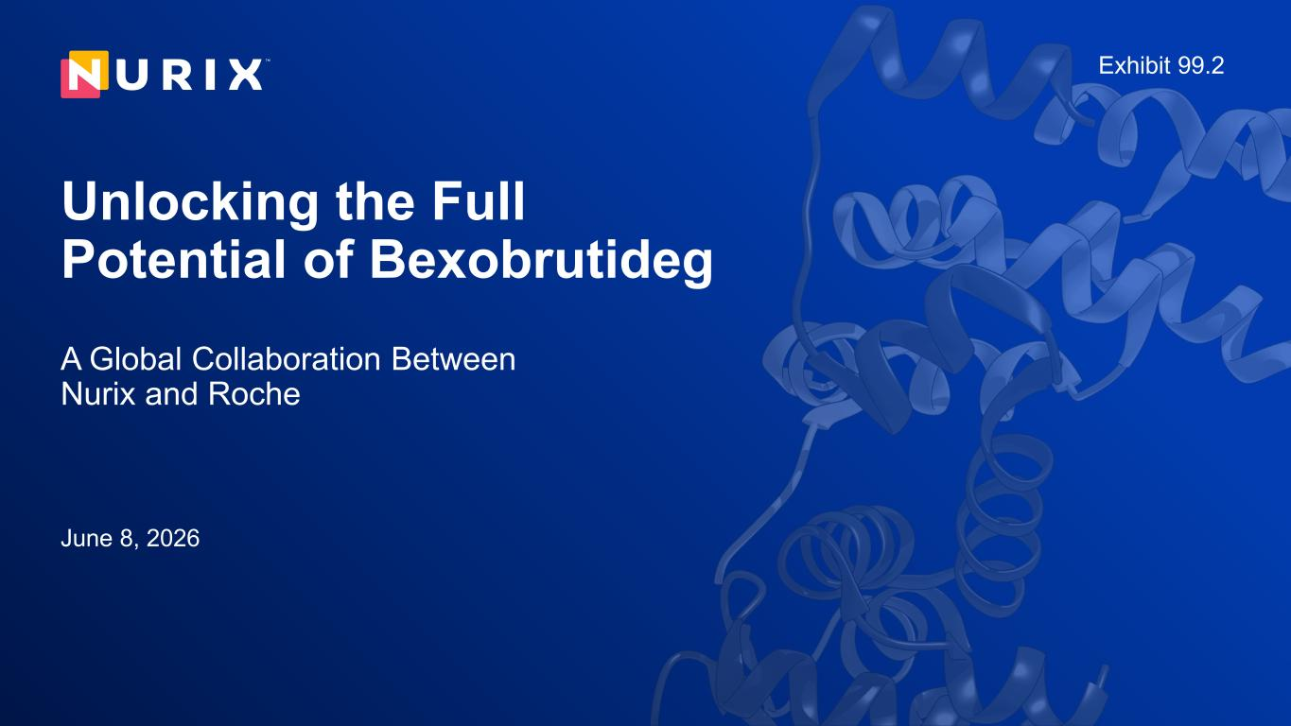
4

Unlocking the Full Potential of Bexobrutideg A Global Collaboration Between Nurix and Roche June 8, 2026 Exhibit 99.2

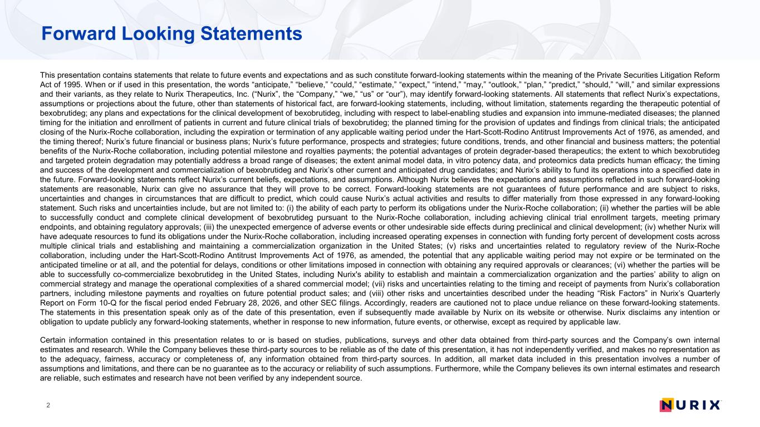
Forward Looking Statements 2 This presentation contains statements that relate to future events and expectations and as such constitute forward-looking statements within the meaning of the Private Securities Litigation Reform Act of 1995. When or if used in this presentation, the words “anticipate,” “believe,” “could,” “estimate,” “expect,” “intend,” “may,” “outlook,” “plan,” “predict,” “should,” “will,” and similar expressions and their variants, as they relate to Nurix Therapeutics, Inc. (“Nurix”, the “Company,” “we,” “us” or “our”), may identify forward-looking statements. All statements that reflect Nurix’s expectations, assumptions or projections about the future, other than statements of historical fact, are forward-looking statements, including, without limitation, statements regarding the therapeutic potential of bexobrutideg; any plans and expectations for the clinical development of bexobrutideg, including with respect to label-enabling studies and expansion into immune-mediated diseases; the planned timing for the initiation and enrollment of patients in current and future clinical trials of bexobrutideg; the planned timing for the provision of updates and findings from clinical trials; the anticipated closing of the Nurix-Roche collaboration, including the expiration or termination of any applicable waiting period under the Hart-Scott-Rodino Antitrust Improvements Act of 1976, as amended, and the timing thereof; Nurix’s future financial or business plans; Nurix’s future performance, prospects and strategies; future conditions, trends, and other financial and business matters; the potential benefits of the Nurix-Roche collaboration, including potential milestone and royalties payments; the potential advantages of protein degrader-based therapeutics; the extent to which bexobrutideg and targeted protein degradation may potentially address a broad range of diseases; the extent animal model data, in vitro potency data, and proteomics data predicts human efficacy; the timing and success of the development and commercialization of bexobrutideg and Nurix’s other current and anticipated drug candidates; and Nurix’s ability to fund its operations into a specified date in the future. Forward-looking statements reflect Nurix’s current beliefs, expectations, and assumptions. Although Nurix believes the expectations and assumptions reflected in such forward-looking statements are reasonable, Nurix can give no assurance that they will prove to be correct. Forward-looking statements are not guarantees of future performance and are subject to risks, uncertainties and changes in circumstances that are difficult to predict, which could cause Nurix’s actual activities and results to differ materially from those expressed in any forward-looking statement. Such risks and uncertainties include, but are not limited to: (i) the ability of each party to perform its obligations under the Nurix-Roche collaboration; (ii) whether the parties will be able to successfully conduct and complete clinical development of bexobrutideg pursuant to the Nurix-Roche collaboration, including achieving clinical trial enrollment targets, meeting primary endpoints, and obtaining regulatory approvals; (iii) the unexpected emergence of adverse events or other undesirable side effects during preclinical and clinical development; (iv) whether Nurix will have adequate resources to fund its obligations under the Nurix-Roche collaboration, including increased operating expenses in connection with funding forty percent of development costs across multiple clinical trials and establishing and maintaining a commercialization organization in the United States; (v) risks and uncertainties related to regulatory review of the Nurix-Roche collaboration, including under the Hart-Scott-Rodino Antitrust Improvements Act of 1976, as amended, the potential that any applicable waiting period may not expire or be terminated on the anticipated timeline or at all, and the potential for delays, conditions or other limitations imposed in connection with obtaining any required approvals or clearances; (vi) whether the parties will be able to successfully co-commercialize bexobrutideg in the United States, including Nurix's ability to establish and maintain a commercialization organization and the parties’ ability to align on commercial strategy and manage the operational complexities of a shared commercial model; (vii) risks and uncertainties relating to the timing and receipt of payments from Nurix’s collaboration partners, including milestone payments and royalties on future potential product sales; and (viii) other risks and uncertainties described under the heading “Risk Factors” in Nurix’s Quarterly Report on Form 10-Q for the fiscal period ended February 28, 2026, and other SEC filings. Accordingly, readers are cautioned not to place undue reliance on these forward-looking statements. The statements in this presentation speak only as of the date of this presentation, even if subsequently made available by Nurix on its website or otherwise. Nurix disclaims any intention or obligation to update publicly any forward-looking statements, whether in response to new information, future events, or otherwise, except as required by applicable law. Certain information contained in this presentation relates to or is based on studies, publications, surveys and other data obtained from third-party sources and the Company’s own internal estimates and research. While the Company believes these third-party sources to be reliable as of the date of this presentation, it has not independently verified, and makes no representation as to the adequacy, fairness, accuracy or completeness of, any information obtained from third-party sources. In addition, all market data included in this presentation involves a number of assumptions and limitations, and there can be no guarantee as to the accuracy or reliability of such assumptions. Furthermore, while the Company believes its own internal estimates and research are reliable, such estimates and research have not been verified by any independent source.


Welcome and Introductions 3 Arthur T. Sands, M.D., Ph.D. President, Chief Executive Officer and Board Director Nurix Therapeutics Jason Kantor, Ph.D. Chief Business Officer Nurix Therapeutics John Northcott Chief Commercial Officer Nurix Therapeutics Hans van Houte Chief Financial Officer Nurix Therapeutics

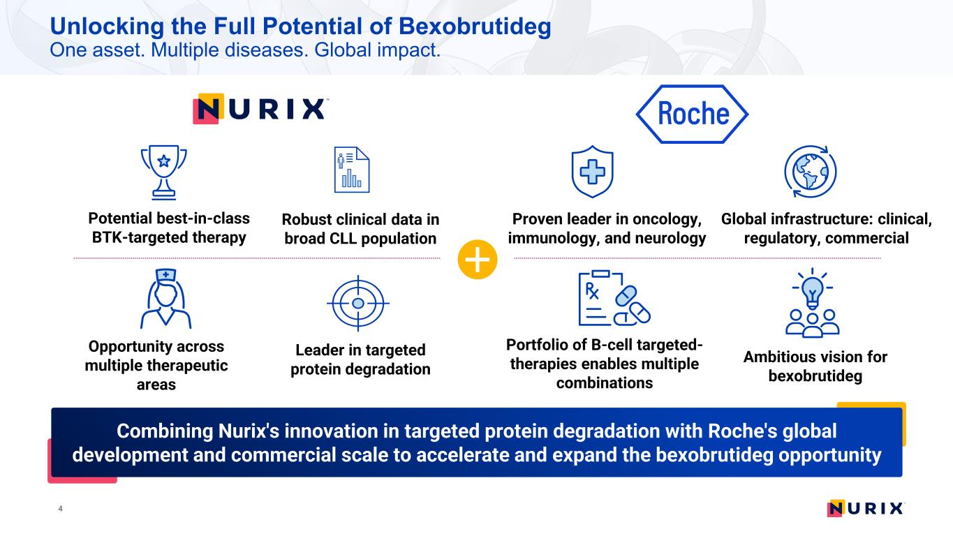
Unlocking the Full Potential of Bexobrutideg One asset. Multiple diseases. Global impact. 4 Potential best-in-class BTK-targeted therapy Opportunity across multiple therapeutic areas Robust clinical data in broad CLL population Leader in targeted protein degradation Proven leader in oncology, immunology, and neurology Portfolio of B-cell targeted- therapies enables multiple combinations Global infrastructure: clinical, regulatory, commercial Ambitious vision for bexobrutideg Combining Nurix's innovation in targeted protein degradation with Roche's global development and commercial scale to accelerate and expand the bexobrutideg opportunity

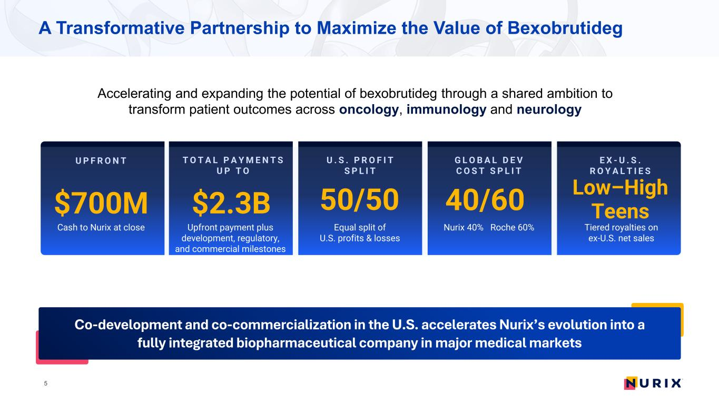
A Transformative Partnership to Maximize the Value of Bexobrutideg Accelerating and expanding the potential of bexobrutideg through a shared ambition to transform patient outcomes across oncology, immunology and neurology 5 Co-development and co-commercialization in the U.S. accelerates Nurix’s evolution into a fully integrated biopharmaceutical company in major medical markets G L O B A L D E V C O S T S P L I T 40/60 Nurix 40% Roche 60% E X - U . S . R O Y A L T I E S Low–High Teens Tiered royalties on ex-U.S. net sales U P F R O N T $700M Cash to Nurix at close T O T A L P A Y M E N T S U P T O $2.3B Upfront payment plus development, regulatory, and commercial milestones U . S . P R O F I T S P L I T 50/50 Equal split of U.S. profits & losses

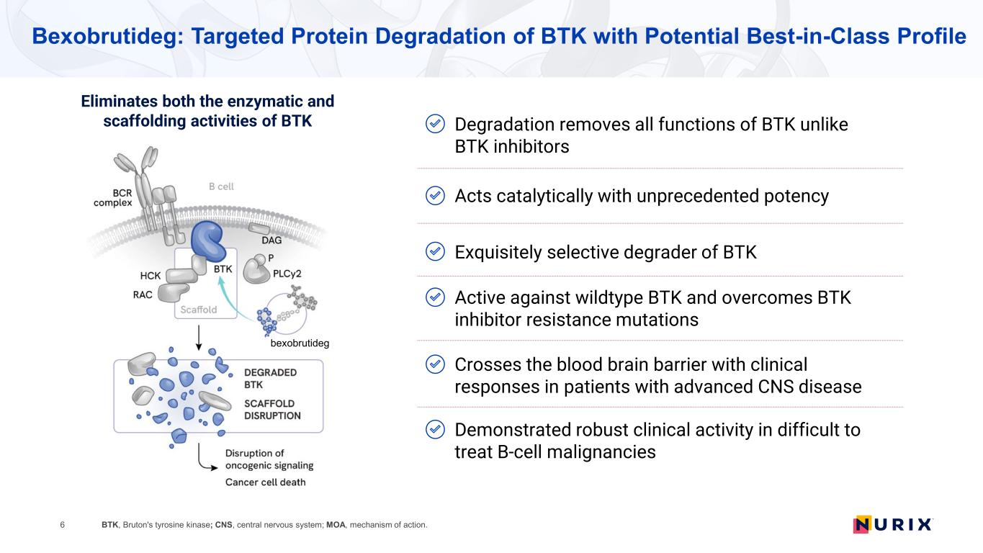
Bexobrutideg: Targeted Protein Degradation of BTK with Potential Best-in-Class Profile 6 Eliminates both the enzymatic and scaffolding activities of BTK Exquisitely selective degrader of BTK Active against wildtype BTK and overcomes BTK inhibitor resistance mutations Demonstrated robust clinical activity in difficult to treat B-cell malignancies Acts catalytically with unprecedented potency Crosses the blood brain barrier with clinical responses in patients with advanced CNS disease Degradation removes all functions of BTK unlike BTK inhibitors BTK, Bruton's tyrosine kinase; CNS, central nervous system; MOA, mechanism of action. bexobrutideg

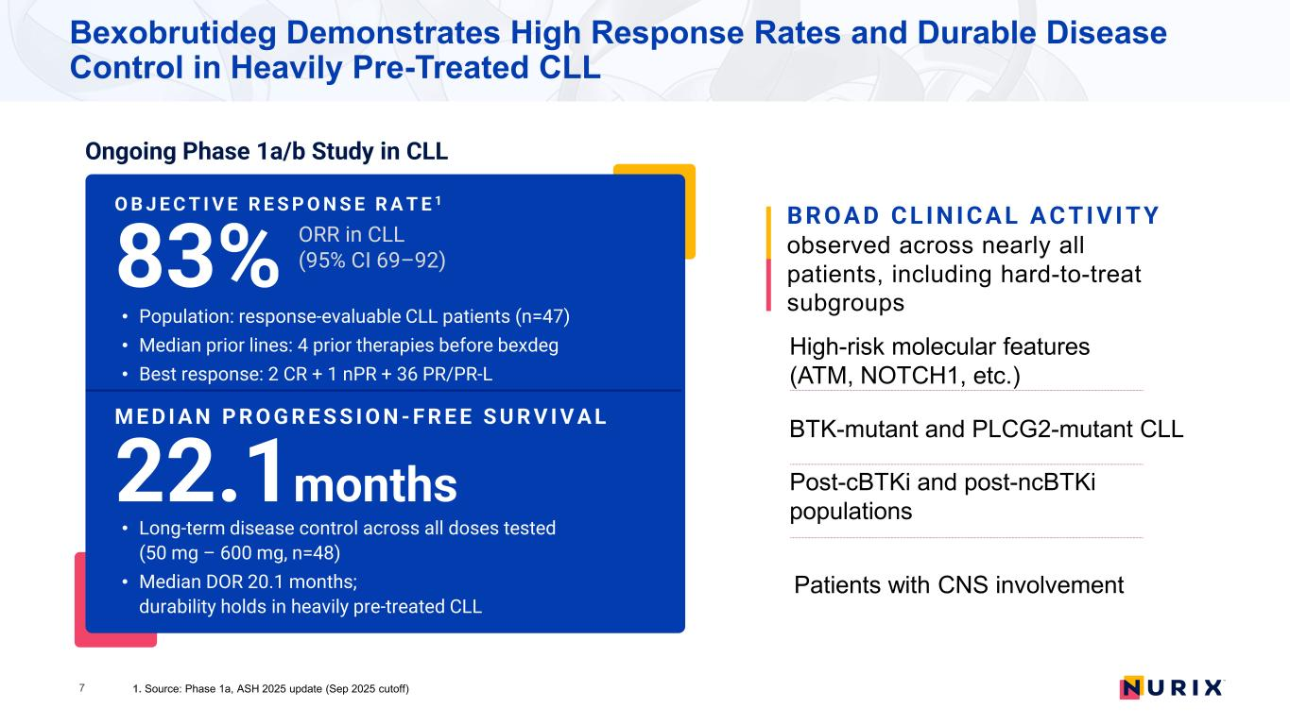
Bexobrutideg Demonstrates High Response Rates and Durable Disease Control in Heavily Pre-Treated CLL ORR in CLL (95% CI 69–92) O B J E C T I V E R E S P O N S E R A T E 1 83% • Population: response-evaluable CLL patients (n=47) • Median prior lines: 4 prior therapies before bexdeg • Best response: 2 CR + 1 nPR + 36 PR/PR-L M E D I A N P R O G R E S S I O N - F R E E S U R V I V A L 22.1months • Long-term disease control across all doses tested (50 mg – 600 mg, n=48) • Median DOR 20.1 months; durability holds in heavily pre-treated CLL Post-cBTKi and post-ncBTKi populations B R OA D C L I N I C A L A C T I V I T Y observed across nearly all patients, including hard-to-treat subgroups High-risk molecular features (ATM, NOTCH1, etc.) Ongoing Phase 1a/b Study in CLL 1. Source: Phase 1a, ASH 2025 update (Sep 2025 cutoff) 7 BTK-mutant and PLCG2-mutant CLL Patients with CNS involvement

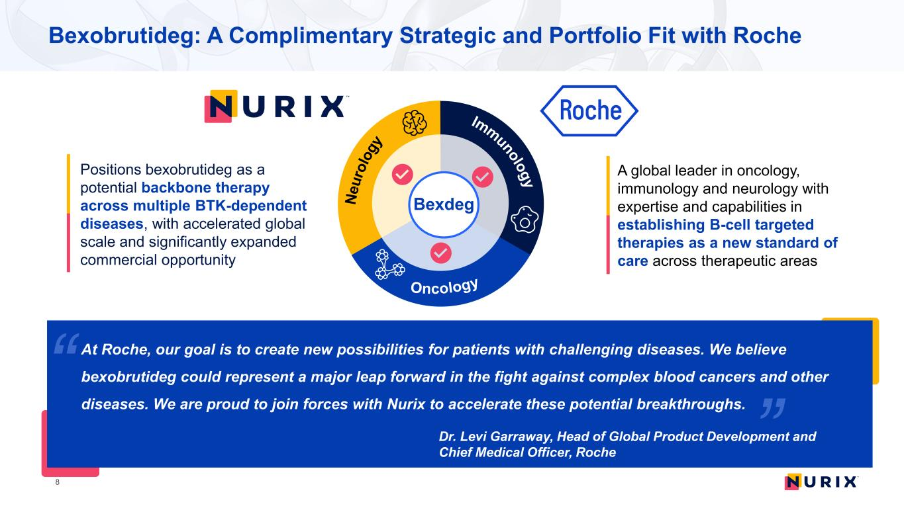
8 A global leader in oncology, immunology and neurology with expertise and capabilities in establishing B-cell targeted therapies as a new standard of care across therapeutic areas Bexobrutideg: A Complimentary Strategic and Portfolio Fit with Roche At Roche, our goal is to create new possibilities for patients with challenging diseases. We believe bexobrutideg could represent a major leap forward in the fight against complex blood cancers and other diseases. We are proud to join forces with Nurix to accelerate these potential breakthroughs​​. Dr. Levi Garraway, Head of Global Product Development and Chief Medical Officer, Roche Bexdeg Positions bexobrutideg as a potential backbone therapy across multiple BTK-dependent diseases, with accelerated global scale and significantly expanded commercial opportunity


9 OUR MISSION To establish degrader-based medicines at the forefront of patient care


Neurology Joint Development Plan A Comprehensive Multi-Indication Program Oncology Immunology 10

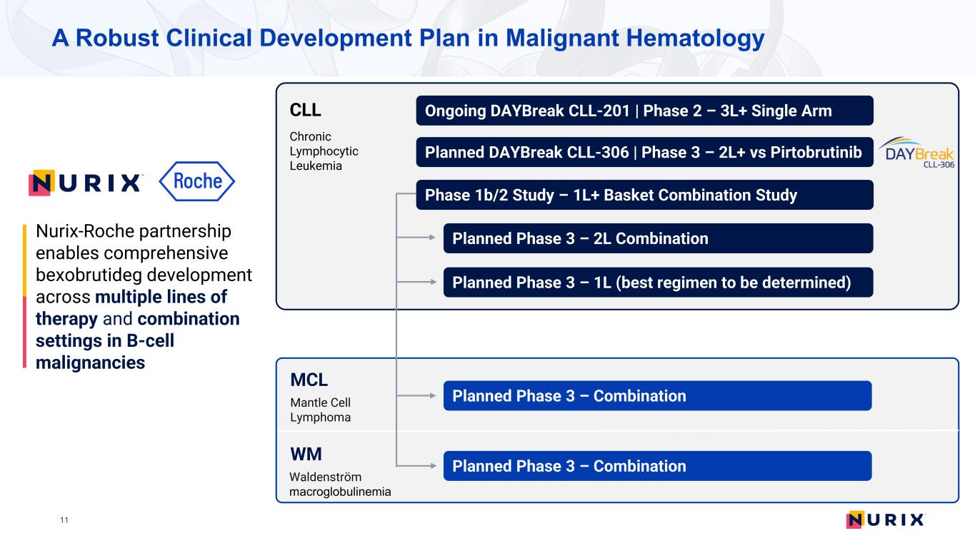
A Robust Clinical Development Plan in Malignant Hematology CLL Chronic Lymphocytic Leukemia Planned DAYBreak CLL-306 | Phase 3 – 2L+ vs Pirtobrutinib Planned Phase 3 – 2L Combination Phase 1b/2 Study – 1L+ Basket Combination Study 11 MCL Mantle Cell Lymphoma WM Waldenström macroglobulinemia Planned Phase 3 – Combination Planned Phase 3 – Combination Ongoing DAYBreak CLL-201 | Phase 2 – 3L+ Single Arm Planned Phase 3 – 1L (best regimen to be determined) Nurix-Roche partnership enables comprehensive bexobrutideg development across multiple lines of therapy and combination settings in B-cell malignancies

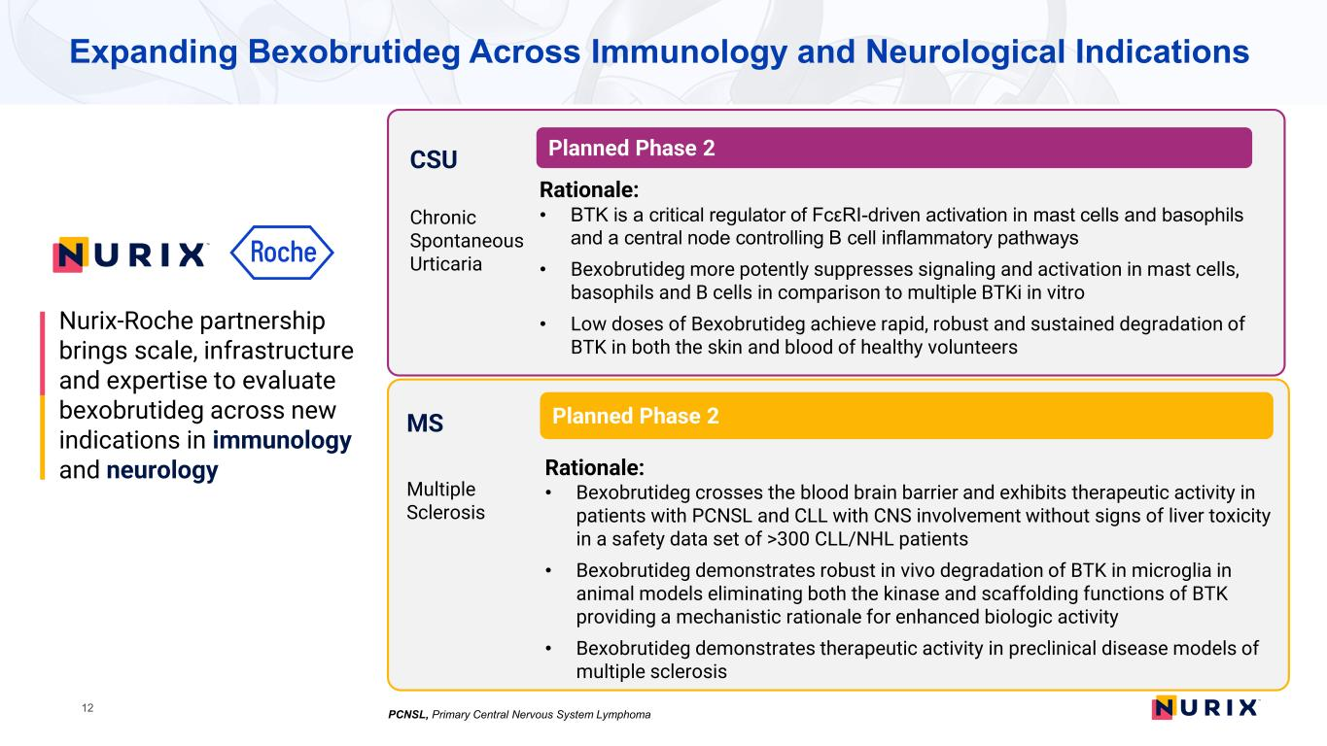
Expanding Bexobrutideg Across Immunology and Neurological Indications CSU Chronic Spontaneous Urticaria Planned Phase 2 Rationale: • BTK is a critical regulator of FcεRI-driven activation in mast cells and basophils and a central node controlling B cell inflammatory pathways • Bexobrutideg more potently suppresses signaling and activation in mast cells, basophils and B cells in comparison to multiple BTKi in vitro • Low doses of Bexobrutideg achieve rapid, robust and sustained degradation of BTK in both the skin and blood of healthy volunteers MS Multiple Sclerosis Planned Phase 2 Rationale: • Bexobrutideg crosses the blood brain barrier and exhibits therapeutic activity in patients with PCNSL and CLL with CNS involvement without signs of liver toxicity in a safety data set of >300 CLL/NHL patients • Bexobrutideg demonstrates robust in vivo degradation of BTK in microglia in animal models eliminating both the kinase and scaffolding functions of BTK providing a mechanistic rationale for enhanced biologic activity • Bexobrutideg demonstrates therapeutic activity in preclinical disease models of multiple sclerosis 12 Nurix-Roche partnership brings scale, infrastructure and expertise to evaluate bexobrutideg across new indications in immunology and neurology PCNSL, Primary Central Nervous System Lymphoma

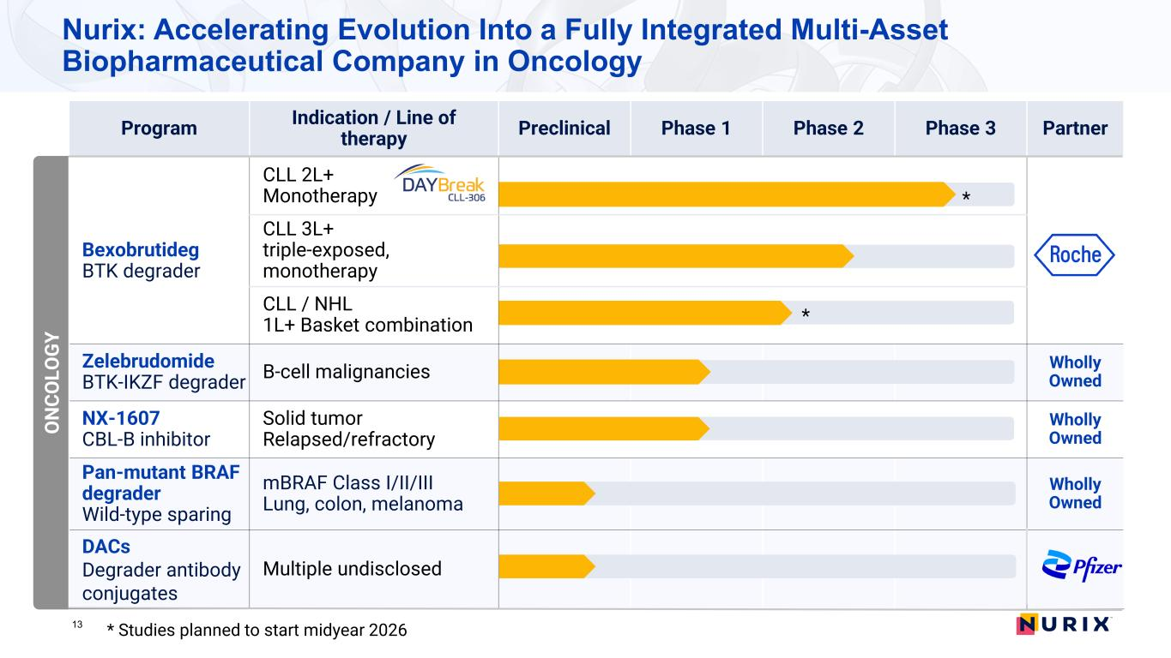
Program Indication / Line of therapy Preclinical Phase 1 Phase 2 Phase 3 Partner Bexobrutideg BTK degrader CLL 2L+ Monotherapy CLL 3L+ triple-exposed, monotherapy CLL / NHL 1L+ Basket combination Zelebrudomide BTK-IKZF degrader B-cell malignancies Wholly Owned NX-1607 CBL-B inhibitor Solid tumor Relapsed/refractory Wholly Owned Pan-mutant BRAF degrader Wild-type sparing mBRAF Class I/II/III Lung, colon, melanoma Wholly Owned DACs Degrader antibody conjugates Multiple undisclosed 13 O N CO LO G Y * * Studies planned to start midyear 2026 * Nurix: Accelerating Evolution Into a Fully Integrated Multi-Asset Biopharmaceutical Company in Oncology

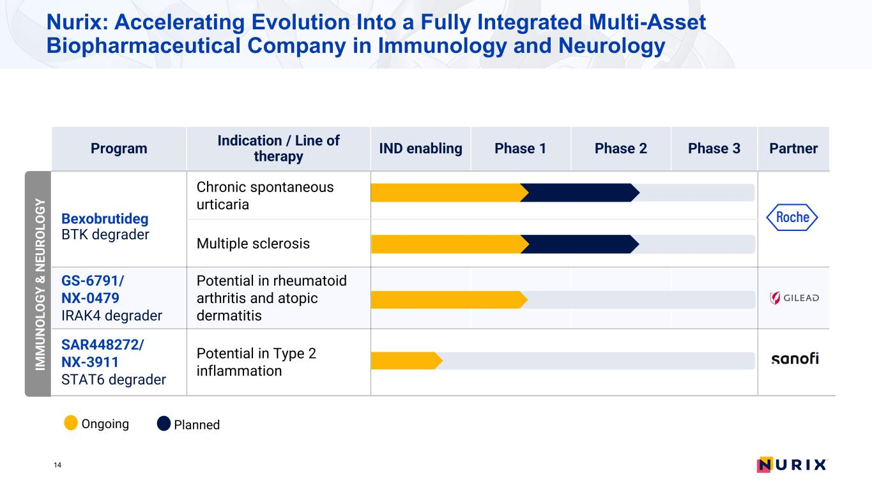
Nurix: Accelerating Evolution Into a Fully Integrated Multi-Asset Biopharmaceutical Company in Immunology and Neurology 14 IM M UN O LO G Y & N EU RO LO G Y Program Indication / Line of therapy IND enabling Phase 1 Phase 2 Phase 3 Partner Bexobrutideg BTK degrader Chronic spontaneous urticaria Multiple sclerosis GS-6791/ NX-0479 IRAK4 degrader Potential in rheumatoid arthritis and atopic dermatitis SAR448272/ NX-3911 STAT6 degrader Potential in Type 2 inflammation Ongoing Planned

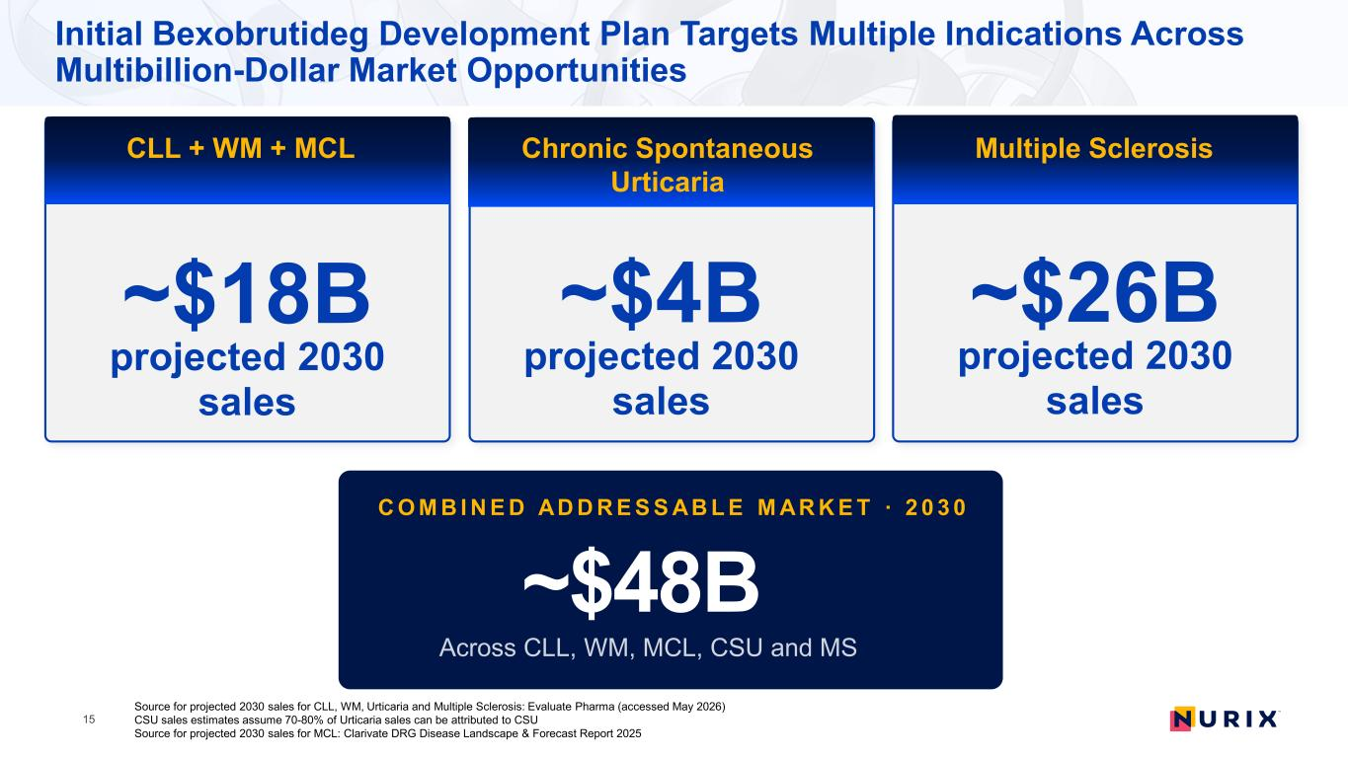
15 ~$26B projected 2030 sales Multiple Sclerosis Source for projected 2030 sales for CLL, WM, Urticaria and Multiple Sclerosis: Evaluate Pharma (accessed May 2026) CSU sales estimates assume 70-80% of Urticaria sales can be attributed to CSU Source for projected 2030 sales for MCL: Clarivate DRG Disease Landscape & Forecast Report 2025 Initial Bexobrutideg Development Plan Targets Multiple Indications Across Multibillion-Dollar Market Opportunities ~$18B projected 2030 sales CLL + WM + MCL ~$4B projected 2030 sales Chronic Spontaneous Urticaria C O M B I N E D AD D R E S S AB L E M AR K E T · 2 0 3 0 ~$48B

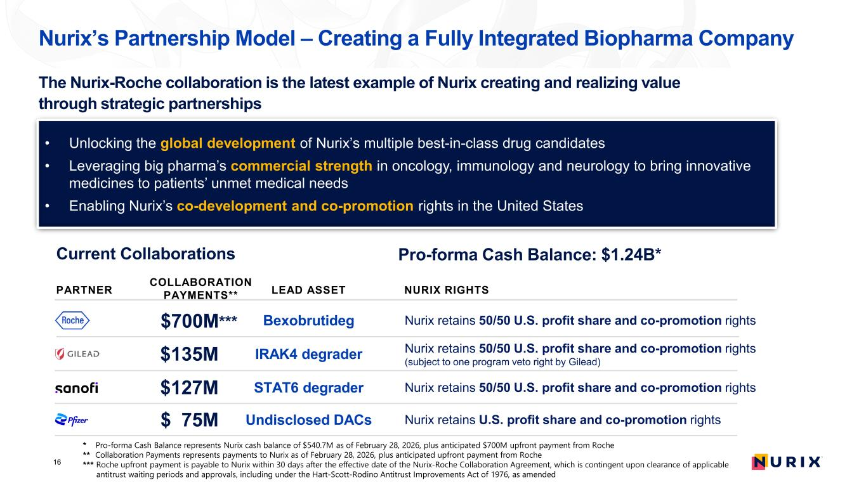
Nurix’s Partnership Model – Creating a Fully Integrated Biopharma Company Current Collaborations PARTNER COLLABORATION PAYMENTS** LEAD ASSET $135M IRAK4 degrader Nurix retains 50/50 U.S. profit share and co-promotion rights (subject to one program veto right by Gilead) • Unlocking the global development of Nurix’s multiple best-in-class drug candidates • Leveraging big pharma’s commercial strength in oncology, immunology and neurology to bring innovative medicines to patients’ unmet medical needs • Enabling Nurix’s co-development and co-promotion rights in the United States 16 * Pro-forma Cash Balance represents Nurix cash balance of $540.7M as of February 28, 2026, plus anticipated $700M upfront payment from Roche ** Collaboration Payments represents payments to Nurix as of February 28, 2026, plus anticipated upfront payment from Roche *** Roche upfront payment is payable to Nurix within 30 days after the effective date of the Nurix-Roche Collaboration Agreement, which is contingent upon clearance of applicable antitrust waiting periods and approvals, including under the Hart-Scott-Rodino Antitrust Improvements Act of 1976, as amended $700M*** Bexobrutideg Nurix retains 50/50 U.S. profit share and co-promotion rights $127M STAT6 degrader Nurix retains 50/50 U.S. profit share and co-promotion rights $ 75M Undisclosed DACs Nurix retains U.S. profit share and co-promotion rights Pro-forma Cash Balance: $1.24B* NURIX RIGHTS The Nurix-Roche collaboration is the latest example of Nurix creating and realizing value through strategic partnerships

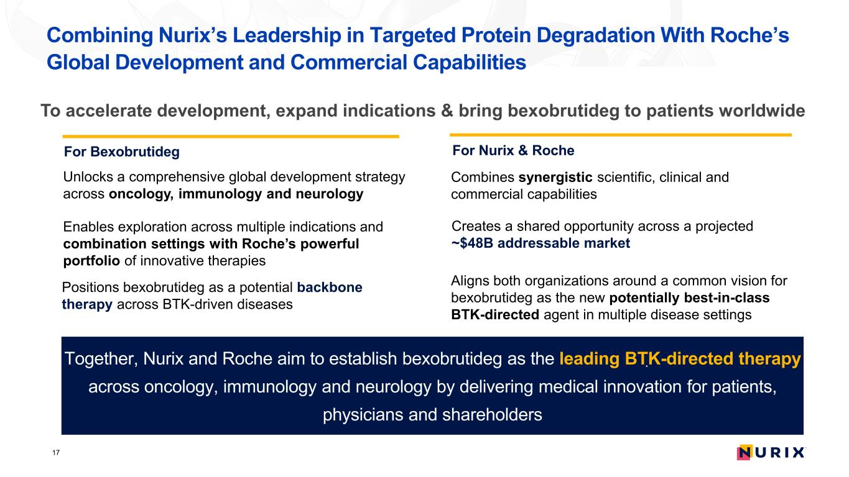
Combining Nurix’s Leadership in Targeted Protein Degradation With Roche’s Global Development and Commercial Capabilities To accelerate development, expand indications & bring bexobrutideg to patients worldwide For Bexobrutideg Unlocks a comprehensive global development strategy across oncology, immunology and neurology Enables exploration across multiple indications and combination settings with Roche’s powerful portfolio of innovative therapies Positions bexobrutideg as a potential backbone therapy across BTK-driven diseases For Nurix & Roche Combines synergistic scientific, clinical and commercial capabilities Creates a shared opportunity across a projected ~$48B addressable market Aligns both organizations around a common vision for bexobrutideg as the new potentially best-in-class BTK-directed agent in multiple disease settings Together, Nurix and Roche aim to establish bexobrutideg as the leading BTK-directed therapy across oncology, immunology and neurology by delivering medical innovation for patients, physicians and shareholders . 17

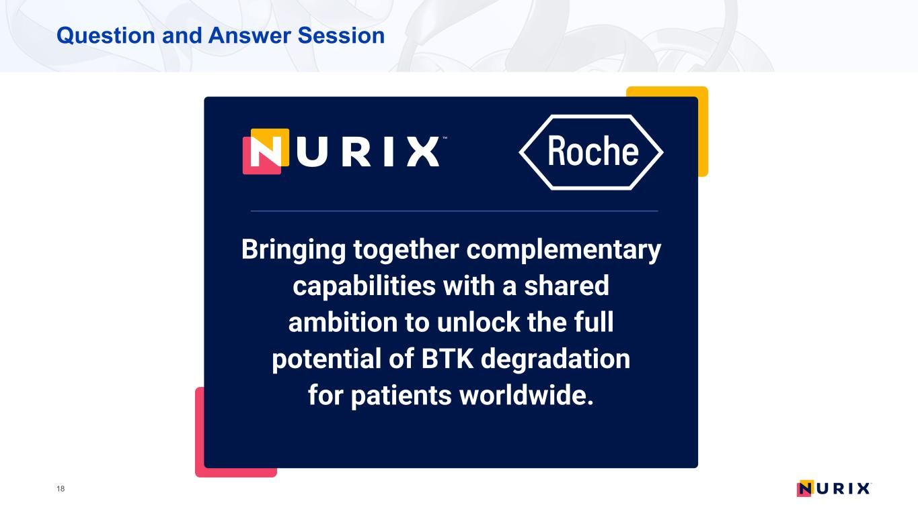
Question and Answer Session 18 z Bringing together complementary capabilities with a shared ambition to unlock the full potential of BTK degradation for patients worldwide.

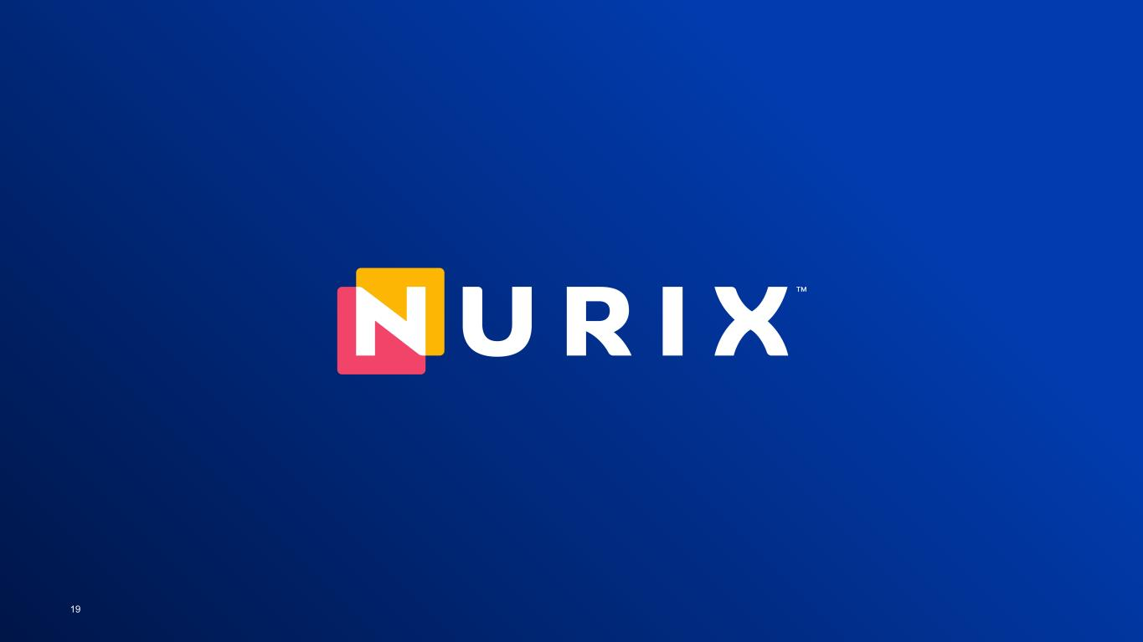
19

